PROJECT DOCUMENTATION
Support AI Ticket Management Agent
An AI-Powered Support Desk for Ticket Raising, Tracking, and Resolution

Prepared by: Leela Lakshmi Sai Ram Nakka
Electronics and Communication Engineering
Vishnu Institute of Technology
Document Type: Project Report
August 2026

Abstract
The Support AI Ticket Management Agent is a web-based support desk application built to modernize how employees within an organization raise, track, and resolve internal support issues. Conventional helpdesk systems require a formal ticket for every issue, even minor ones that could be resolved instantly with the right guidance, which inflates ticket volume, delays attention to genuinely complex problems, and adds avoidable load on support staff. This project addresses that gap by combining a structured, transparent ticket management workflow with an integrated conversational AI agent, powered by Google Gemini, that gives employees an immediate, self-service path for common hardware, credential, and software questions before a formal ticket is ever raised.
The application is secured behind an authentication flow so that every ticket and AI Agent conversation is tied to a verified employee identity. Once signed in, users land on a live dashboard summarizing total, open, in-progress, and resolved tickets, with quick access to either consult the AI Agent or raise a new ticket. Every ticket carries an ID, employee, department, subject, priority, status, and creation date, and the shared ticket queue is searchable and filterable across the team. The interface is delivered as a responsive single-page application with a collapsible sidebar and full light and dark mode support.
The resulting system demonstrates how a conventional ticketing workflow can be meaningfully improved by embedding a conversational AI layer directly into the support experience. By offering a fast, self-service resolution path for routine issues while preserving a transparent, trackable queue for everything else, the application reduces avoidable support load and improves response time for issues that genuinely require human attention. Its modular architecture — authentication, dashboard, ticketing, and AI Agent — also leaves clear room for future extension, such as automated ticket triage, AI-suggested priority tagging, or analytics on recurring issue categories.

1. Project Statement

1.1 Overview
The Support AI Ticket Management Agent is a web-based support desk application designed to streamline how employees raise, track, and resolve internal support issues. It combines a conventional ticket management workflow with an integrated conversational AI agent, allowing users to get instant answers to common hardware, credential, and software questions before deciding whether a formal ticket is even necessary.

1.2 Problem Statement
Organizations typically rely on manual or semi-automated helpdesk systems where employees must raise a ticket for every issue, even simple ones that could be resolved instantly with the right guidance. This creates unnecessary ticket volume, delays resolution for genuinely complex issues, and increases the workload on support staff. There was a need for a system that reduces low-value ticket creation, gives employees self-service troubleshooting support, and still provides a structured, transparent ticket queue for issues that do require human or process-level intervention.

1.3 Objectives
- Provide a secure sign-up and sign-in flow so only authenticated employees can access the support desk.
- Give users a live, at-a-glance dashboard summarizing total, open, in-progress, and resolved tickets.
- Allow employees to raise tickets with department, subject, and priority classification.
- Maintain a searchable, filterable ticket queue visible across the team, ordered by recency.
- Offer an AI Agent that can answer hardware, credential, and operational questions directly in chat, reducing avoidable ticket volume.
- Present a clean, responsive interface with light and dark mode support.

2. Proposed Solution
The Support AI Ticket Management Agent solves the problem by combining two complementary paths inside a single interface: a traditional ticket-raising and tracking workflow, and a conversational AI Agent that resolves simple issues instantly. When an employee logs in, the dashboard immediately surfaces the current state of the ticket queue — total, open, in-progress, and resolved counts — along with a shortcut to either consult the AI Agent or raise a new ticket, nudging users toward self-service resolution first.
Every ticket carries an ID, the employee and department it belongs to, a subject line, a priority level, a status, and a creation date, giving support staff full visibility at a glance. The AI Agent is purpose-built for quick troubleshooting on password resets, port-binding errors, and hardware guidance, using natural conversational responses.

3. Technology Stack

3.1 Frontend
- Single-page application with a persistent, collapsible sidebar (Dashboard, Raise Ticket, Open Tickets, AI Agent, About, Settings).
- Responsive layout with light/dark theme toggle.

3.2 Backend & Data
- REST-style backend service handling authentication and ticket CRUD operations, backed by a persistent data store for accounts and the shared ticket queue.

3.3 AI Integration
- Conversational AI Agent powered by Google Gemini, answering hardware, credential, and software questions in natural language.

4. Application Walkthrough — Login and Sign Up
Access to the support desk is gated behind an authentication flow. New employees create an account with a username, email address, and password, while existing employees sign in with their username or email and password. This ensures every raised ticket and AI Agent conversation is tied to a verified employee identity.

4.1 Create Account
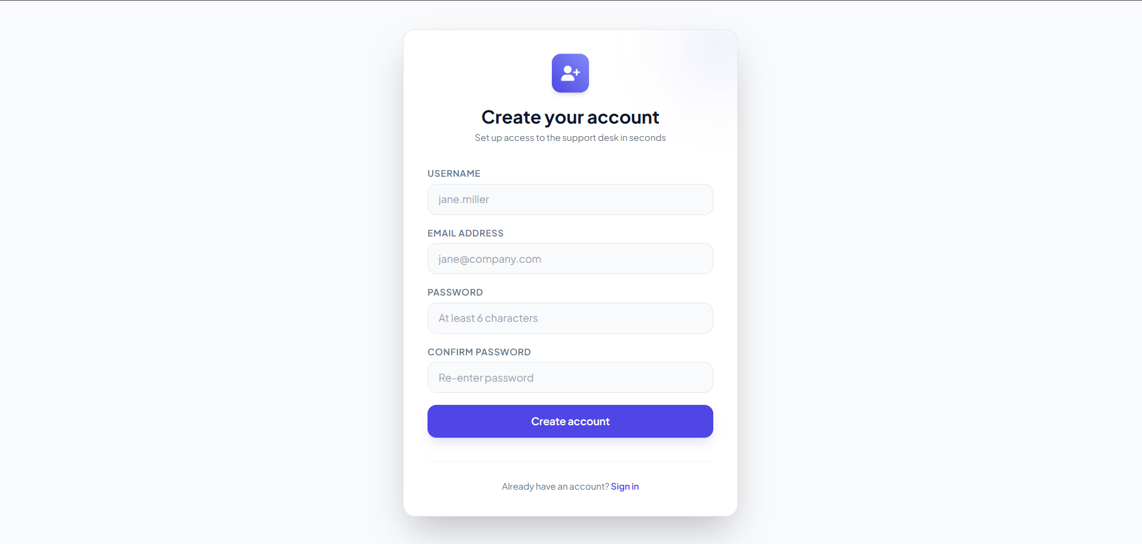
Figure 1: Create Account screen — username, email, password, and confirm-password fields.

4.2 Sign In
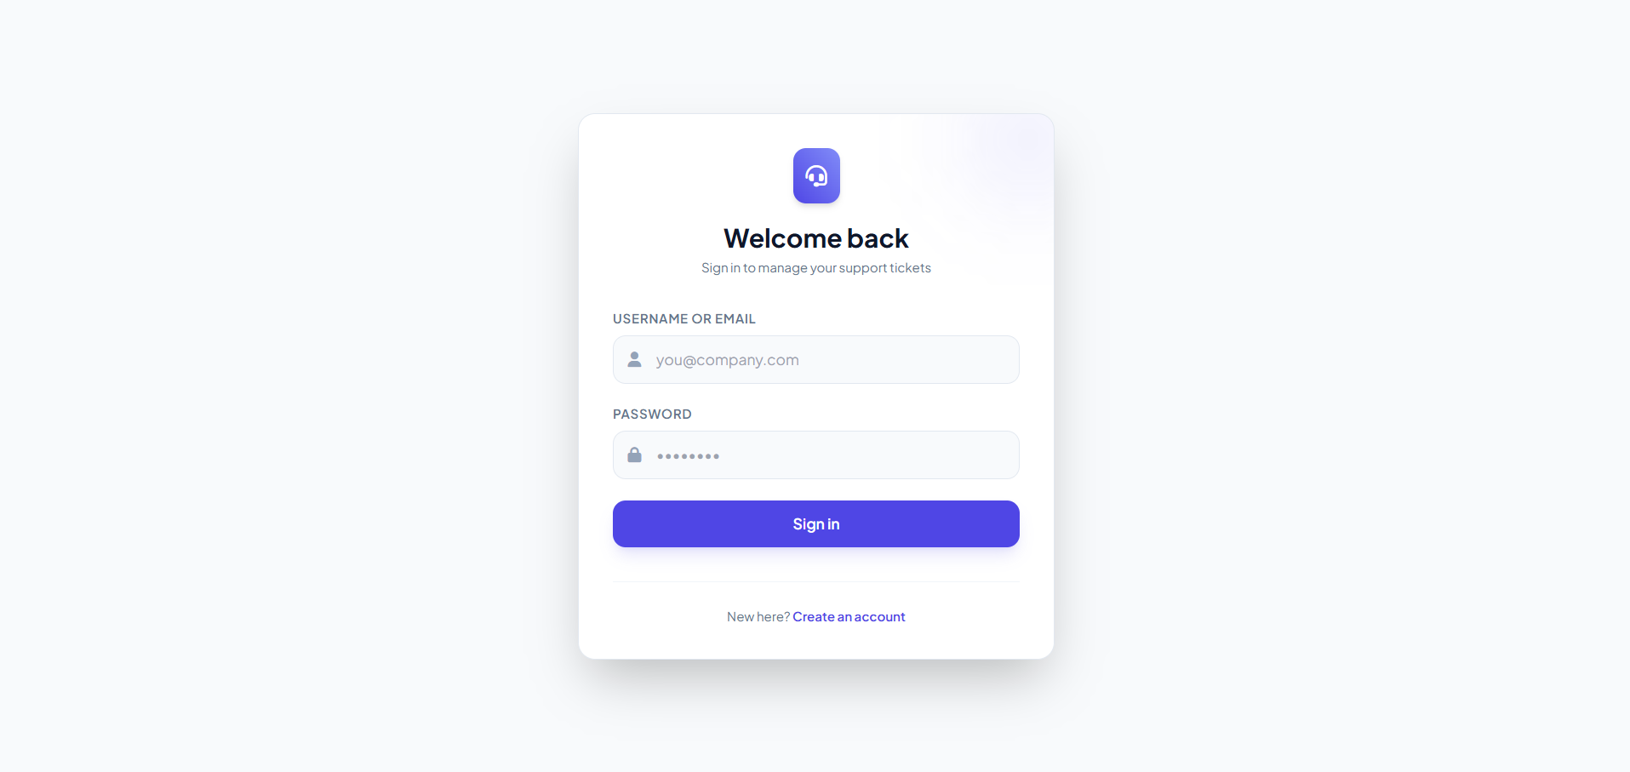
Figure 2: Welcome Back sign-in screen for returning users.

5. Application Walkthrough — Main Web Page and Features

5.1 Support Overview Dashboard
Once signed in, the user lands on the Support Overview dashboard, which shows live ticket counts, recent tickets with priority tags, and quick actions to consult the AI Agent or raise a ticket.
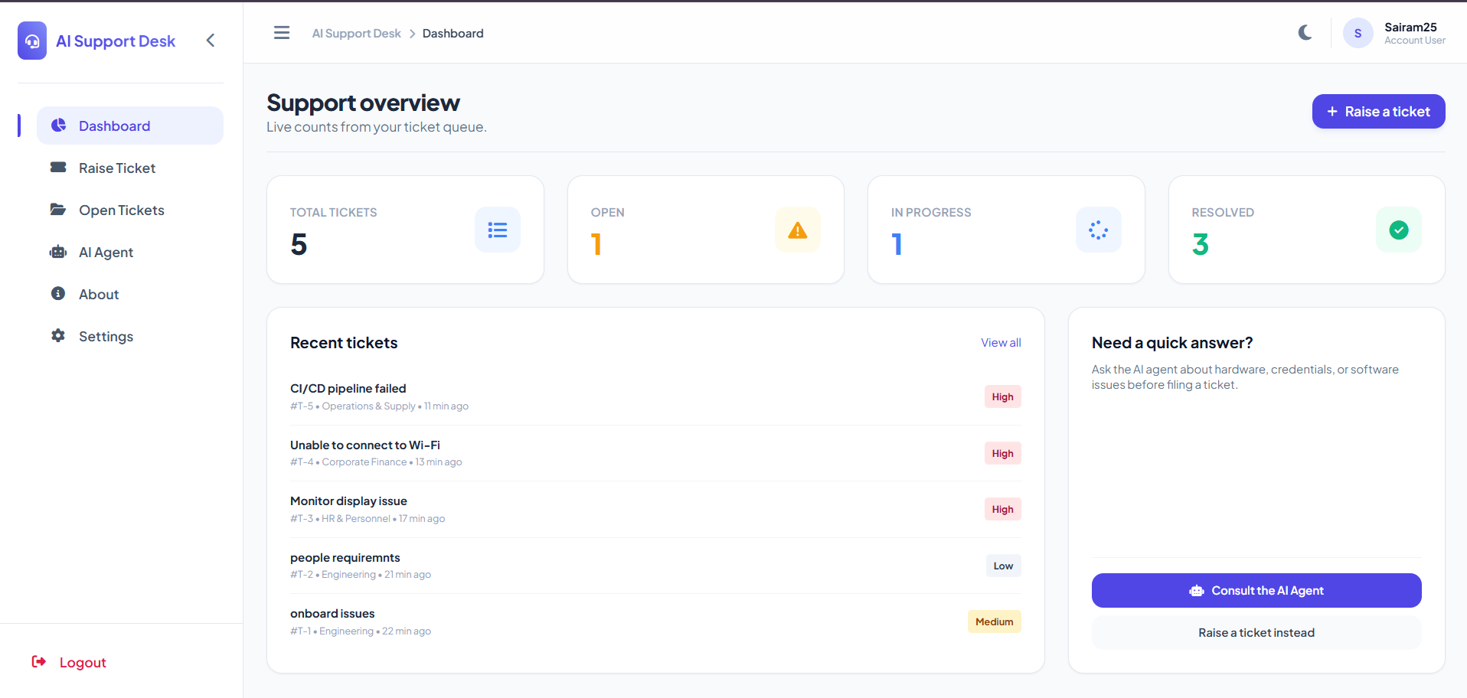
Figure 3: Support Overview dashboard with live ticket counts and recent tickets.

5.2 Navigation and Features
The sidebar provides access to every core feature: Dashboard, Raise Ticket, Open Tickets, AI Agent, About, and Settings, and can be collapsed to maximize workspace.
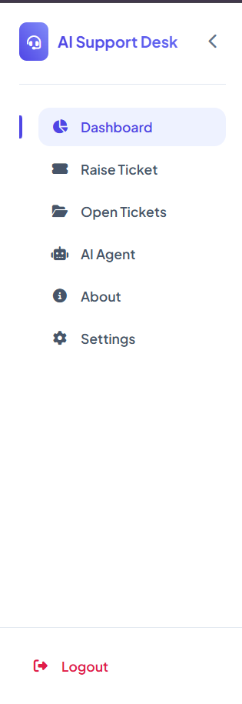
Figure 4: Sidebar navigation showing all available features of the application.

6. Application Walkthrough — AI Agent and Ticket Management

6.1 AI Agent
The AI Agent page lets employees describe a hardware issue, credential problem, or operational question and receive an immediate, conversational answer powered by Google Gemini, with suggested prompts to get started quickly.
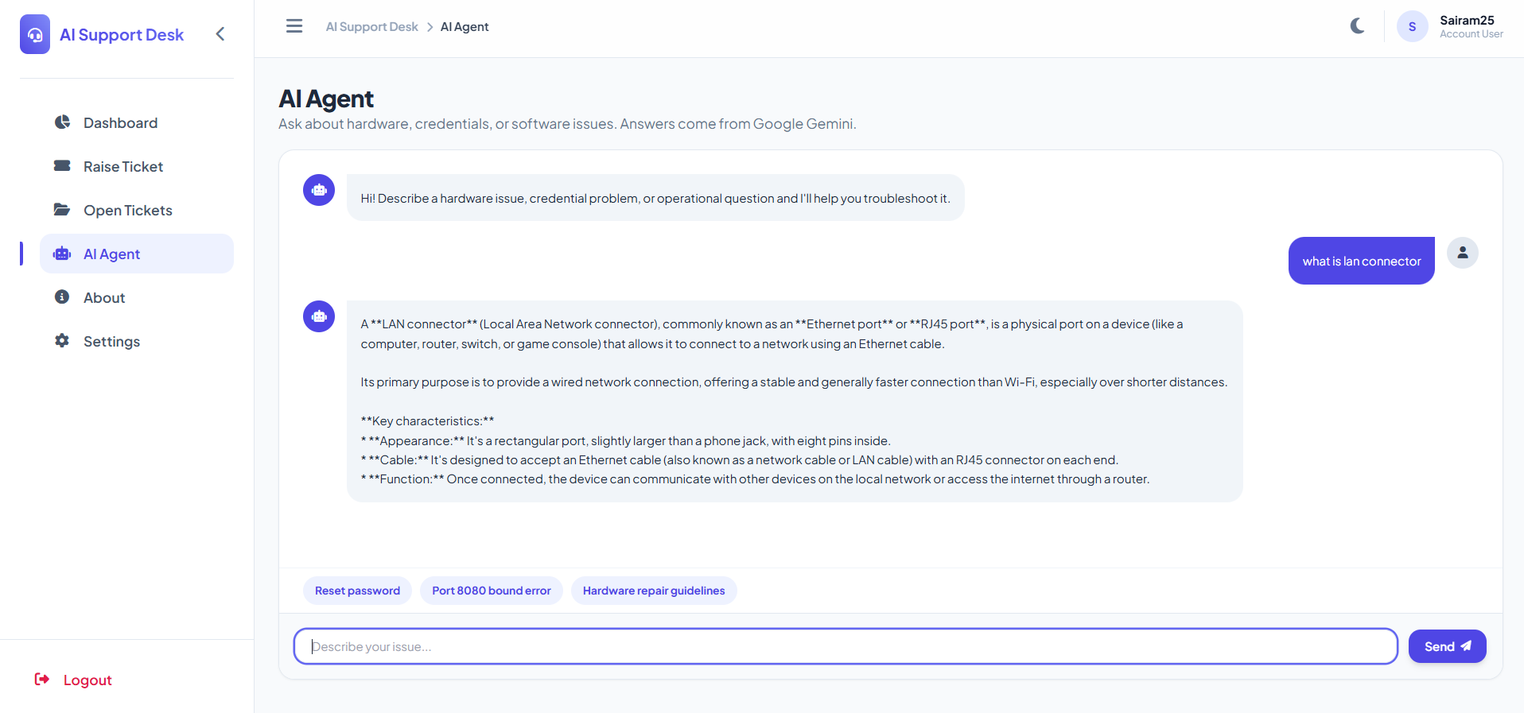
Figure 5: AI Agent chat interface answering a user's question in real time.

6.2 Ticket Management
The ticket queue lists every ticket raised across the team, newest first, searchable by title or employee and filterable by department or status, showing ticket ID, employee, department, subject, priority, status, and creation date.
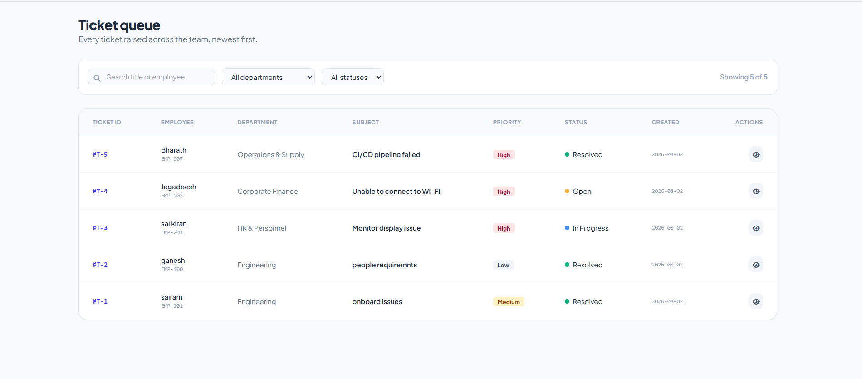
Figure 6: Ticket queue showing every raised ticket with filters and status tracking.

7. Outcome and Conclusion

7.1 Outcome
- Delivered a fully functional support desk with secure authentication, ticket lifecycle tracking, and AI-assisted troubleshooting in a single interface.
- Reduced friction for employees by letting them attempt self-service resolution through the AI Agent before raising a ticket.
- Gave support staff a centralized, filterable, real-time view of ticket volume and status across departments.
- Achieved a clean, responsive UI with dark mode support, consistent across dashboard, ticketing, and AI Agent modules.

7.2 Conclusion
The Support AI Ticket Management Agent demonstrates how a conventional ticketing workflow can be meaningfully improved by embedding a conversational AI layer directly into the support experience. By giving employees a fast, self-service path for common issues while preserving a transparent, trackable ticket queue for everything else, the system reduces avoidable support load and improves response time for the issues that genuinely need human attention. The modular structure of the application — authentication, dashboard, ticketing, and AI Agent — also makes it straightforward to extend with future capabilities such as automated ticket triage, AI-suggested priority tagging, or analytics on recurring issue types.

